# CHALLENGE-01

Launch one Linux instance in aws. 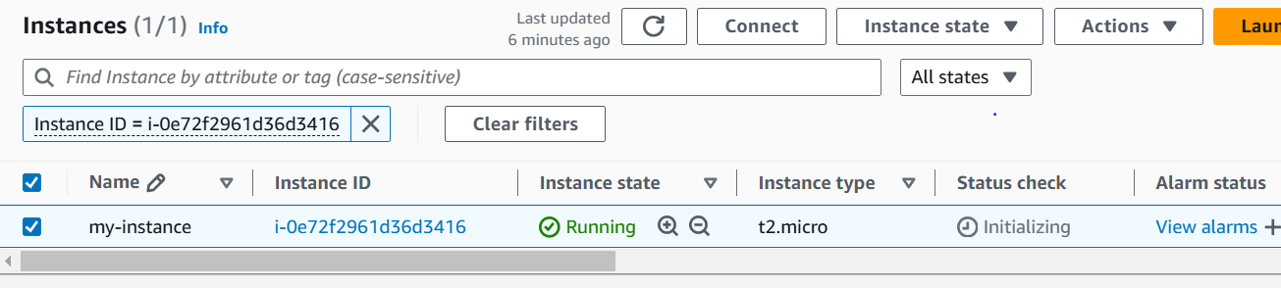

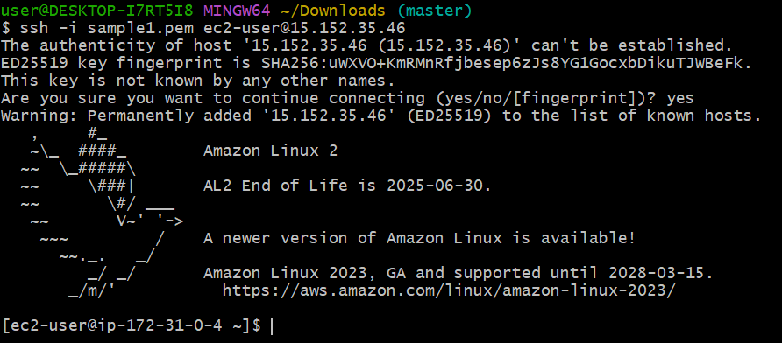

2)Create on file with name Techie_horizon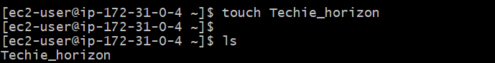

3) Copy the file "Techie_Horizon" from aws instance to windows machine.

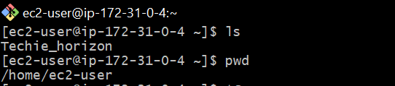

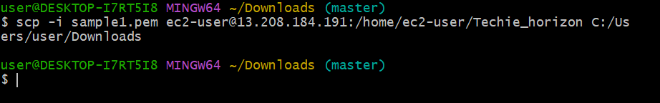

Output:

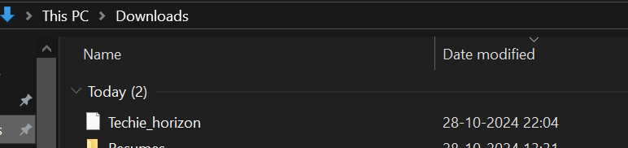

4)Install Jenkins in the server created in step 1.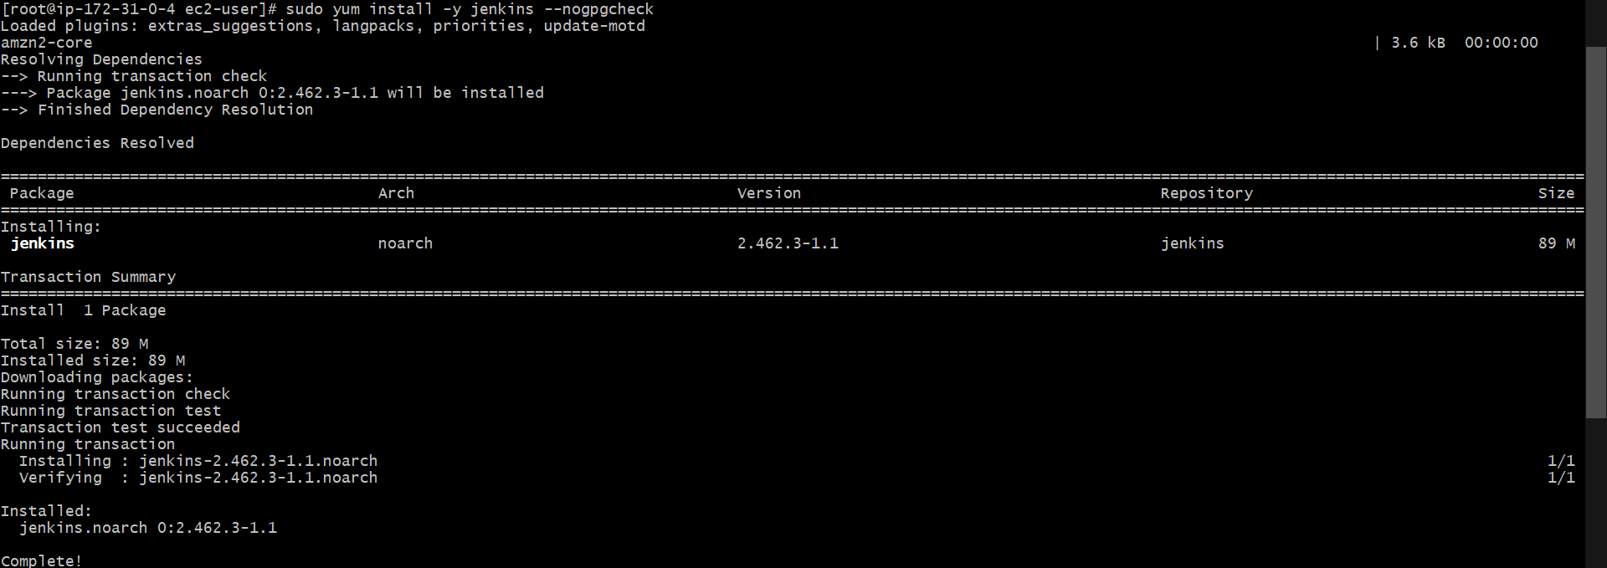

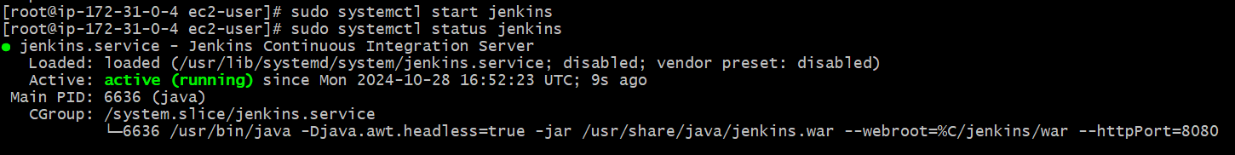

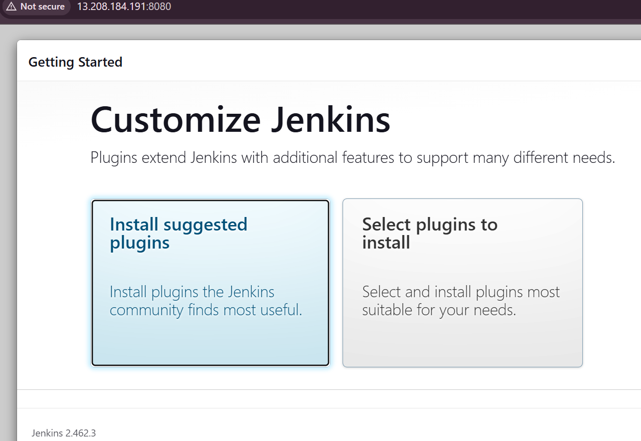

5)Install httpd,nginx,Apache Tomcat.

Installing httpd 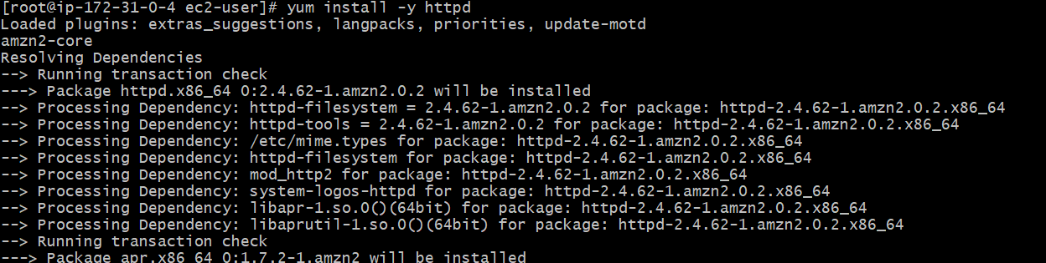 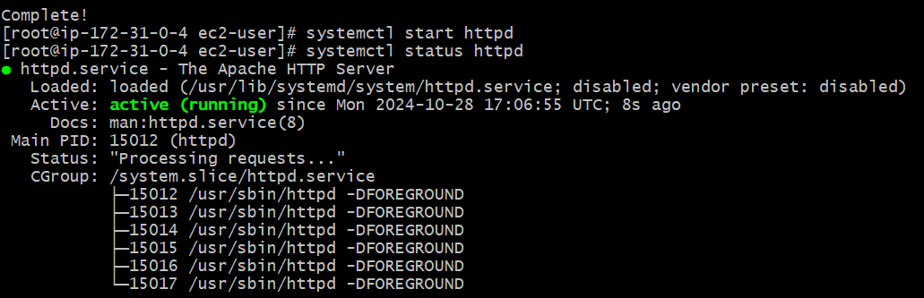

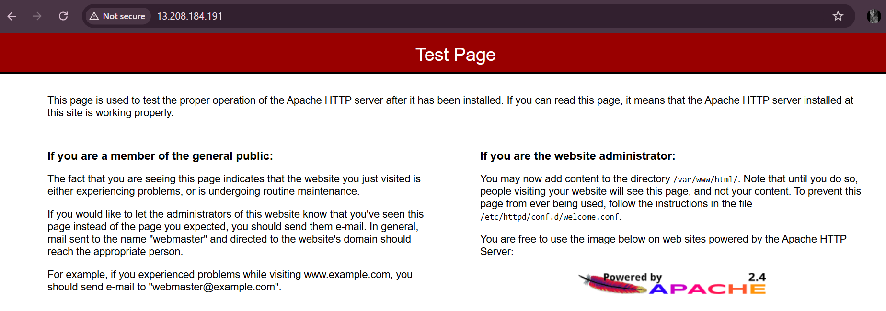

Nginx:

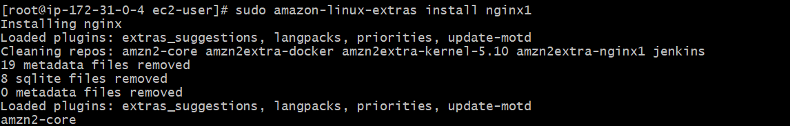 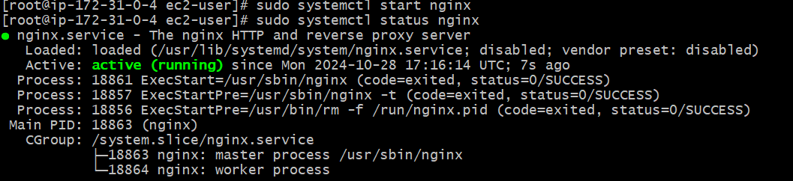

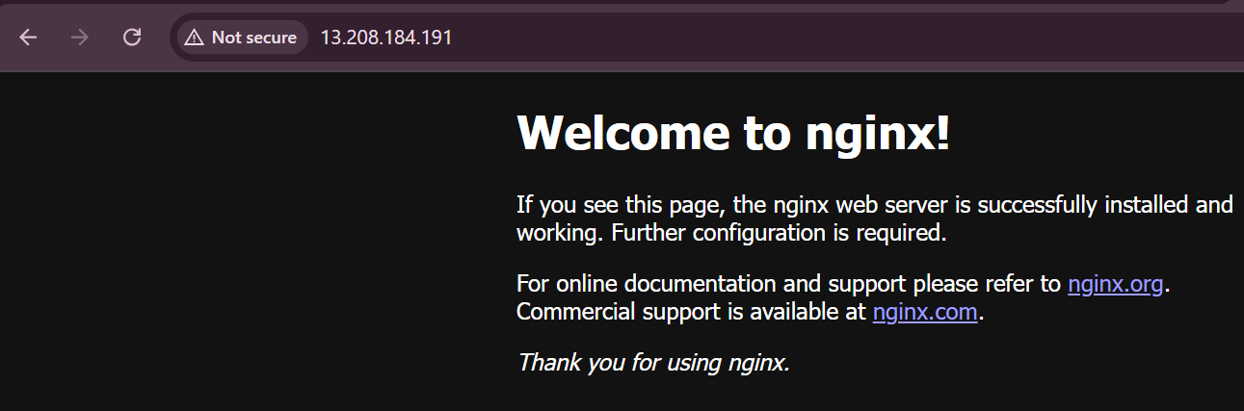

Apache Tomcat: 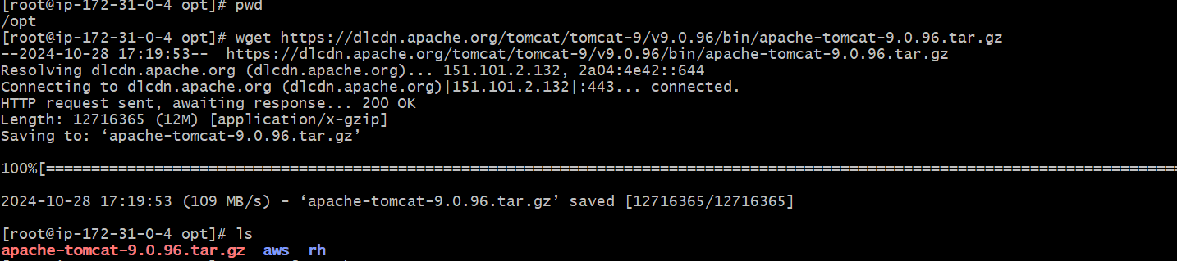

Step:2

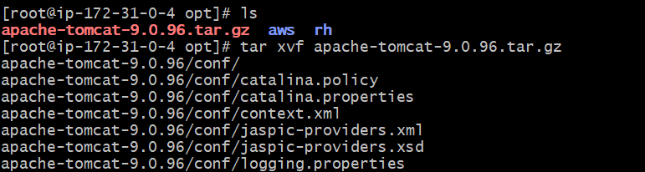

Step:3

